Furthermore, since much of the energy of a CHP system is consumed on-site as a form of distributed generation, less energy is lost through transmission, adding to the energy savings. However, the feasibility of developing CHP at such sites depends on a large and constant need for waste heat throughout the year. The disparate rates of capacity and generation decline shown in Figure 1 suggest that, beyond facility additions and retirements, change in operation at existing facilities may be an important consideration in developing reliable demand forecasts and accurately assessing California’s progress toward policy goals. (“Combined Heat and Power.Pdf,” n.d.).

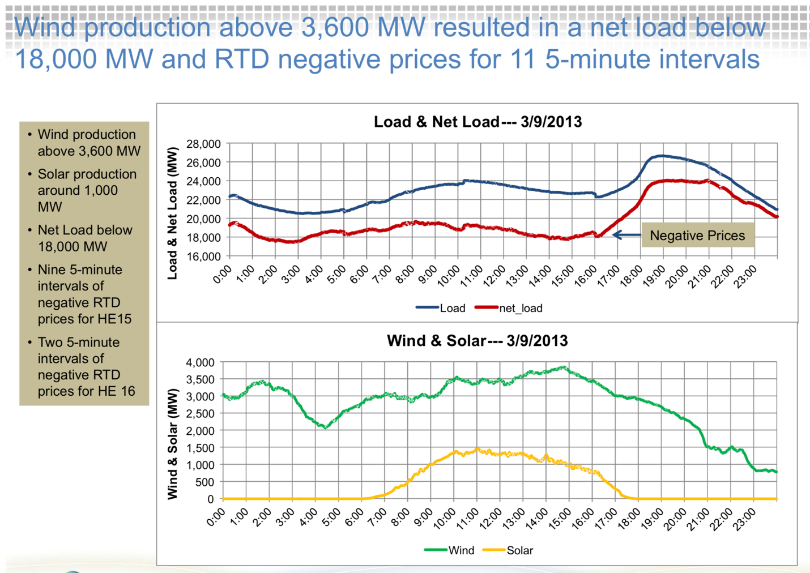

As California’s population growth has shifted, so too has California’s new construction. Accordingly, updates to the *Building Energy Efficiency Standards* have gradually shifted focus from developing new space and water heating requirements to establishing and enhancing space cooling requirements, including solar heat gain requirements for windows and solar reflectance requirements for roofs. Understanding the location of new construction in California is essential both for identifying efficiency opportunities in newly constructed buildings and for determining where, and in what amount, on-site renewable energy generation is both technically feasible and cost-effective for the consumer (Commission, 2017).

